Assignment-29.2:

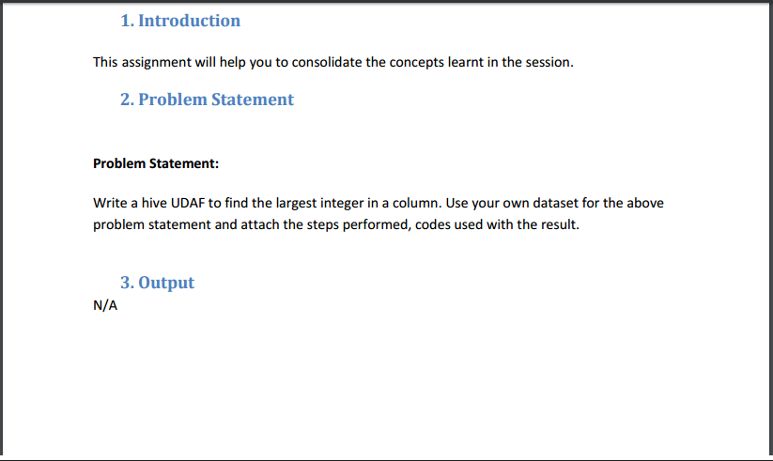

Program:

**STEP 1: WRITING JAVA CODE TO FIND LARGEST INTEGER IN THE COLUMN**

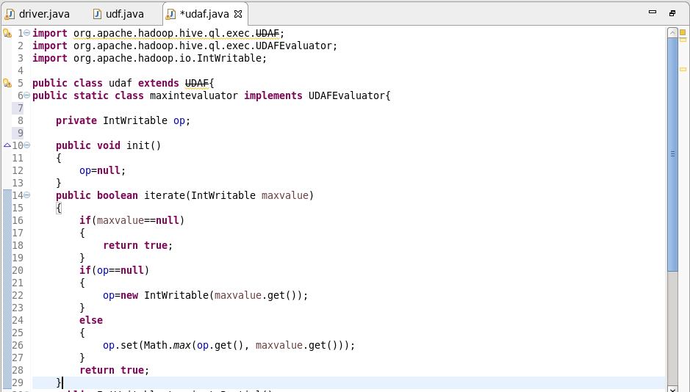 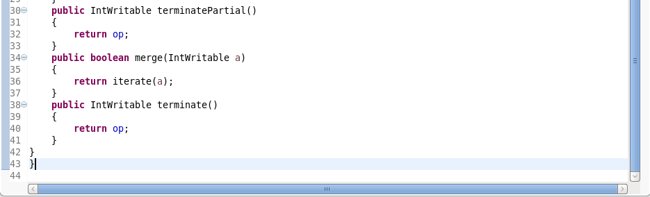

1. init() – The init() method initializes the evaluator and resets its internal state. We are using new Column() in the code below to indicate that no values have been aggregated yet.
2. iterate() – this method is called every time there is a new value to be aggregated. The evaulator should update its internal state with the result of performing the aggregation (We return true to indicate that the input was valid.
3. terminatePartial() – this method is called when Hive wants a result for the partial aggregation. The method must return an object that encapsulates the state of the aggregation.
4. merge() – this method is called when Hive decides to combine one partial aggregation with another.
5. terminate() – this method is called when the final result of the aggregation is needed.

Adding the Jar file:

I am using the employee table to find the maximum salary.

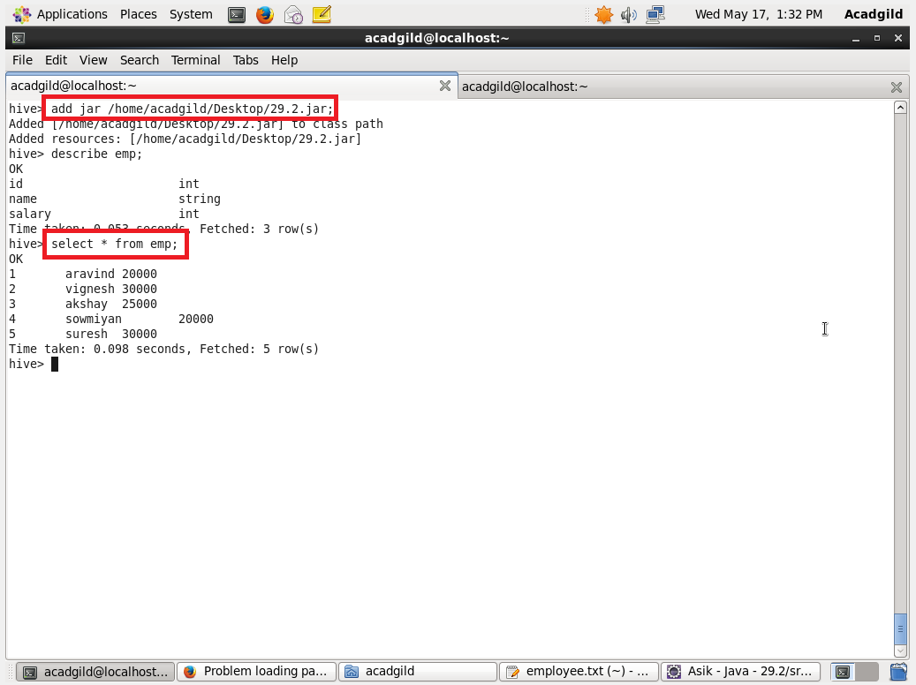

Creating a temporary function and getting the maximum salary from the table.

